# PIPELINE 2

Vo Hieu Nghia

Ex1:

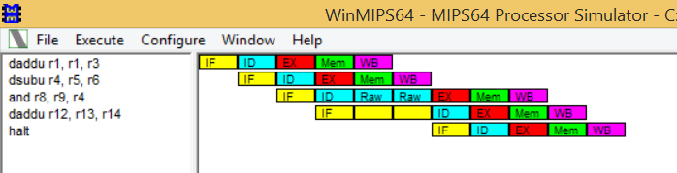

Ex2:

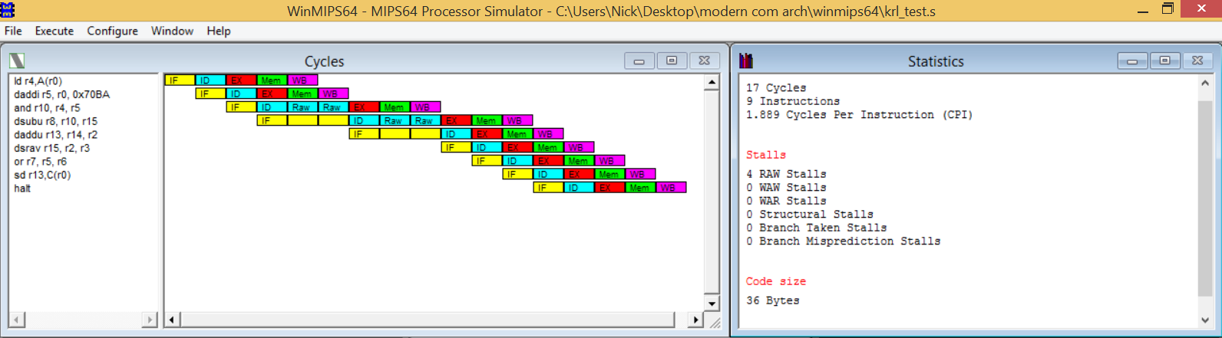

Answer:

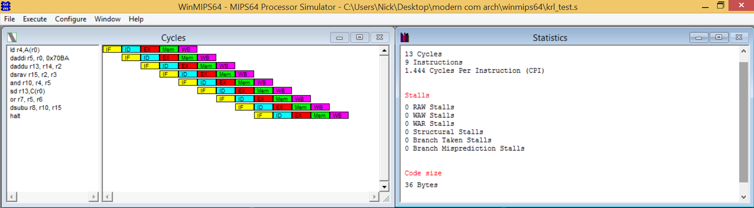

Ex3:

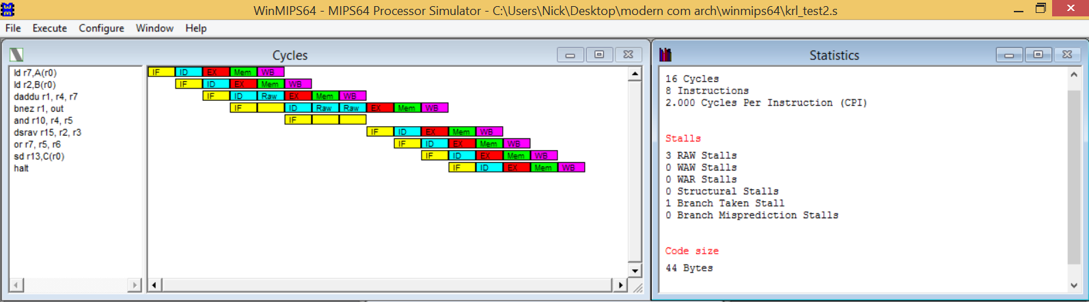

Answer: Enable forwarding reduce one cycle in the instruction, which is RAW stall, and reduce the cycle numbers. Enable delay slot will execute the instruction, which should be skipped. As the consequence, the number of branch taken stalls are reduced but the instruction numbers will be increased.

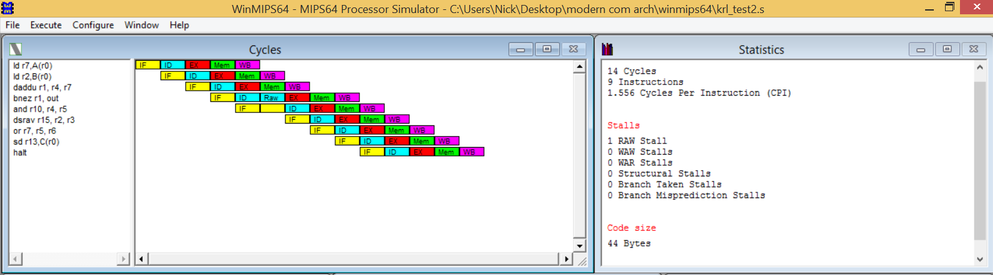

Ex4:

|  |  |  |  |
| --- | --- | --- | --- |
|  | No enable | Enable forwarding | Enable forwarding & branch target buffer |
| Execution |  |  |  |
| Cycles | 2591 | 1894 | 1701 |
| Instructions | 1293 | 1293 | 1293 |
| CPI | 2.004 | 1.465 | 1.316 |
| Stalls |  |  |  |
| RAW stalls | 1095 | 398 | 398 |
| Branch taken stalls | 199 | 199 | 6 |

In this exercise, the more we enable, the more cycles, CPI and number of hazards will be reduced. When the forwarding is enable, the cycles and CPI decrease 27% and raw stalls drop 64%. However, the Instructions and the branch taken stalls are the same. When both forwarding and branch target buffer enable, the cycles drop 34%, CPI decrease and raw stalls sill drop 64%. The difference in this option is that the instructions’ number is still the same but the branch taken stalls drop down to 97%.

Therefore, the forwarding minimizes the data hazard stalls and the branch target buffer helps to control branch hazards and if we enable both, the performance will be much greater.